Esercizio SQL

<https://www.sqlservertutorial.net/>

Prendere in considerazione il database School rappresentato dal seguente diagramma

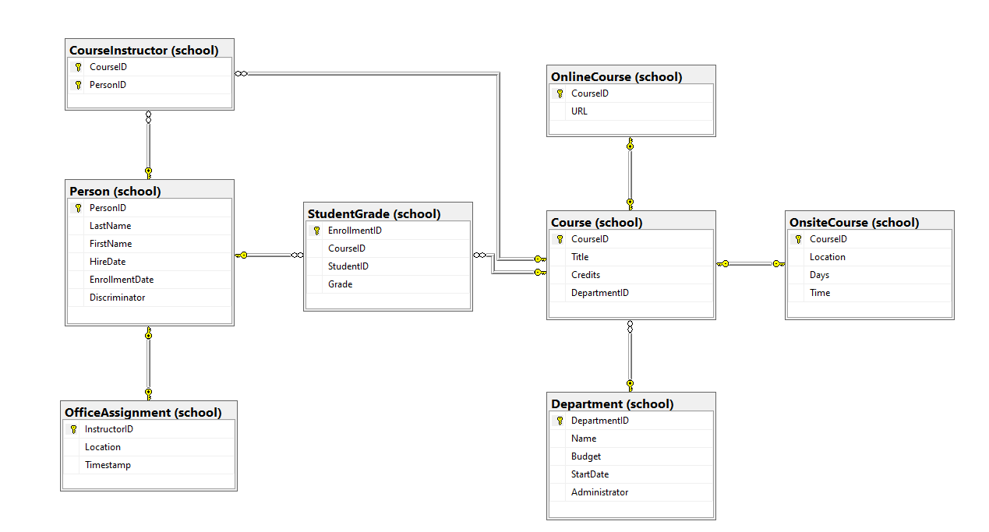

e scrivere le istruzioni SQL necessarie per estrarre le seguenti informazioni:

1. il budget medio dei dipartimenti

| select avg(budget) from Department |
| --- |

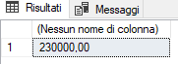

1. i dipartimenti che hanno un budget superiore alla media

| select name from Department where budget > (select avg(budget) from Department) |
| --- |

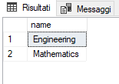

1. il dipartimento con il budget più alto

| select name from Department where budget = (select max(budget) from Department) |
| --- |

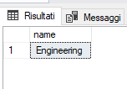

1. l’elenco dei dipendenti

| select LastName,FirstName from Person where discriminator = 'Instructor' |
| --- |

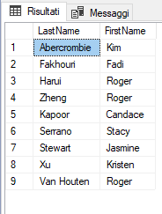

1. il numero di studenti

| select count(discriminator) as n_studenti from Person where discriminator = 'student' |
| --- |

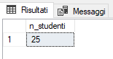

1. le persone che si chiamano Roger

| select FirstName,LastName from Person where FirstName = 'Roger' |
| --- |

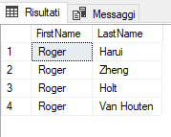

1. gli studenti che si chiamano Roger

| select FirstName,LastName from Person where FirstName = 'Roger' and Discriminator = 'student' |
| --- |
|  |

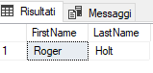

1. l’elenco degli studenti in ordine alfabetico

| select LastName,FirstName from Person where Discriminator = 'student' order by LastName asc |
| --- |

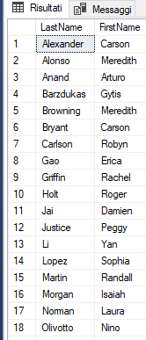

1. gli studenti che si sono iscritti nel 2000

| select LastName,FirstName from Person where Discriminator = 'student' and YEAR(EnrollmentDate) = 2000 |
| --- |

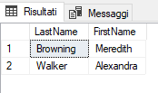

1. il dipendente che ha l’anzianità più alta

| Select FirstName,LastName from Person  where Discriminator = 'Instructor' and HireDate = (select min(HireDate) from Person) |
| --- |

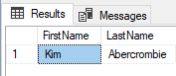

1. i nomi dei corsi onsite

| select Title from Course INNER JOIN OnsiteCourse on Course.CourseID = OnsiteCourse.ID |
| --- |

1. i nomi dei corsi online

| select Title from Course INNER JOIN OnlineCourse on Course.CourseID = OnlineCourse.ID |
| --- |

1. il nomi dei corsi e i nomi dei dipartimenti di appartenenza

| select Course.Title,Department.Name from school.Course  inner join school.Department on  Course.DepartmentID = Department.DepartmentID |
| --- |

1. il numero di corsi per ogni dipartimento

| Select Name, count(*) as totale from department  inner join Course on department.departmentID = Course.departmentID group by department.Name |
| --- |

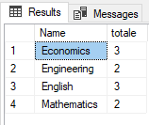

1. i dipartimenti con più di 3 corsi

| Select Name, count(*) from school.department inner join school.Course on school.department.departmentID = school.Course.deartmentID group by school.department.Name having count(*) > 3 |
| --- |

1. il dipartimento con più corsi

| Select Name, count(*) from department inner join Course on department.departmentID = Course.DepartmentID group by department.Name having count(*) = (  Select max(totale) from  (Select count(*) as totale from department  inner join Course on department.departmentID = Course.departmentID group by department.Name) as t) |
| --- |

or

<https://www.sqlservertutorial.net/sql-server-views/>

| create view department_courses as select Name, count(*) as totale from department inner join Course on department.departmentID = Course.DepartmentID group by department.Name |
| --- |

| select * from department_courses where totale = (select max(totale)from department_courses) |
| --- |